BIRD OF PREY VISIT AND PHOTOGRAPHS
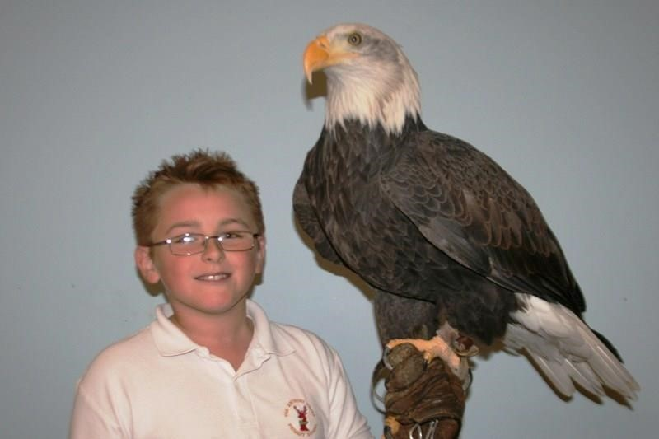

On ……………...(Insert DATE) the children will be having a talk given to them about the ecology and conservation of Birds of Prey by Mr. Alan Ames, (The Birdman) founder of Eagle Heights Wildlife Foundation in Eynsford, Kent. They will meet four different birds. By bringing the birds to schools, Mr. Ames highlights the need for conservation, and explains to the children about predators, ecology, adaption and how the natural world works.
After the presentation there will be an opportunity for the children to have their photograph taken holding one of the birds on their gloved hand. The photograph will be 7” x 5” in a mount, and will cost £7.00. (siblings can have one photograph together). There is also the option to purchase additional copies at £3.00 each.
If you wish your child/children to be photographed, please fill in the slip below and return it to your child’s class teacher together with the money by ………………………………………… (INSERT DATE)
Without permission slips and payment, photographs cannot be taken.
The photographs will be ready for collection at the school approximately 5-6 working days after the visit.
GDPR COMPLIANCE : The photographs are taken by Mr. Ames on a digital camera. The images are downloaded onto a laptop and the images erased from the memory card. The images are then uploaded to www.photobox.co.uk who print the pictures and send them directly to the school. The images are stored on the laptop for 28 days in case any duplicate pictures are requested or any get damaged in transit. The images are then permanently deleted. Images or pictures are not shared with any other third party or published elsewhere.
Vulnerable children. The photograph can printed at the school and the digital image deleted immediately.
………………………………………………………………………………………………………………

BIRD OF PREY PHOTOGRAPHS

I give permission for, Child’s name ....................................... Class.................to be photographed with a bird of prey.

Signed ………………………………… Parent/Guardian

£7 for one …….........£7 ………… Additional copies at each £3 ...……. £………….

